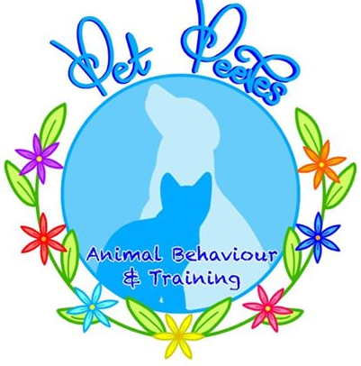
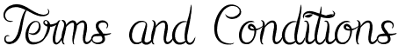

Pet Peeves does all it reasonably can do to provide a safe and healthy training environment for you and your dog. Please see below T&Cs that apply to any and all 1-2-1 training sessions.
Please note that payment for services and engaging in the training session both also imply full agreement with these Terms and Conditions.

Techniques and Handling Methods
The training techniques and behaviour modification methods used by Pet Peeves Animal Behaviour are designed to be kind, fair, force-free and non-aversive. Harsh handling of dogs, physical force and the use of punitive methods/ punishment/ corrections or equipment designed to be aversive (including choke chains, check chains, prong collars, spray collars, e-collars or any other device deemed unacceptable by the trainer/ behaviourist) are not to be used.

Payment, Refunds and Cancellations
Payment by bank transfer is required within 48 hours of booking a training session, unless otherwise agreed by Pet Peeves. Sessions can be re-arranged or refunded in full with at least two weeks’ notice. Any cancellation made with between two weeks’ and 48 hours notice of the booked session will be eligible for a refund of any costs paid, less the non-refundable deposit of £20. With less than 48 hours’ notice, no refund will be given for the preparation/report aspect of the package but will be re-arranged for a fee of £10.
Payment and refunds for any sessions are made as per the Terms and Conditions for One to One Training, as set out below:
Amount of Notice Given | Refund? | Re-arrangement fee?  (cost of purchasing a new session)
More than 2 weeks before the booked session | Full Refund (if you haven’t receive the pack) | N/A – simply swap the session
Between 2 weeks + 1 week of the booked session | Partial Refund (minus £20) | Re-arrange for £15
Between 1 week + 2 days of the booked session | 50% Refund | Re-arrange for £15
Less than 48 hours before the booked session | No Refund | Re-arrange for £15

In the event that we have to cancel a session with you due to unforeseen circumstances, such as adverse weather/ illness/ emergency, we will make every effort to reschedule your session to another mutually convenient time. If this is not possible, we will refund you for the cost of the session and any follow-up visits which are also cancelled as a result of this.

Safety
We ask that, unless previously agreed with us, all dogs are kept away from the front door and are contained in another room when we first arrive please. If your dog has ever bitten a person or other animal, you must report this to us before the day of the scheduled 1-2-1 session so that we can advise you accordingly.

Parking
If we are visiting your home, please make a parking place available if possible. If not, and there is on-street parking which requires a visitor permit, please have a visitor permit ready for our use when we arrive. If parking at your home (or other venue at which we have arranged to meet) requires payment, please can we kindly ask that you make arrangements for this.

Children
Children are welcome to be present at training session and encouraged to take part, although due to the nature of the discussions that will be taking place, this may not always be appropriate. It is the responsibility of the parents/ carers to determine whether or not it would be helpful or appropriate for any children/ other family members to be present at any point. We accept no responsibility for children and it is the responsibility of the supervising adult to ensure that children are safe and their well-being is protected at all times whether before, during or after the training session.

Privacy and Marketing
Photographs of your dog may, with your permission, be taken. Such photos may be used by Pet Peeves Animal Behaviour for record keeping and/ or marketing purposes. If you do not wish for photographs of you and/ or your dog to be taken, used or shared, please just let us know. Any written feedback (eg. by email or on feedback forms) may be used for marketing purposes (for example, posted on the website). Only the first name of the person will be used as identification. If you are not happy for us to use your feedback in this way, please just let us know. Permission must be granted by us before any photography or videography of training/ behaviour sessions with Pet Peeves takes place. We are happy to provide a copy on request.

Engagement and Commitment
By consulting Pet Peeves Animal Behaviour and Training with regard to your dog’s behaviour, you agree to fully engage with the process to the best of your ability and understand that any changes will involve commitment and consistency,

Disclaimer and Waiver of Liability
I understand that working with dogs and modifying behaviour poses a risk of injury. I agree to ensuring that necessary steps are taken at all times to prevent injury to myself, my dog(s) and others, including the use of a muzzle and avoidance of situations that might trigger aggressive behaviour. I agree to indemnify and hold harmless Pet Peeves (Raychel Hill) against any and all losses, liabilities, judgments, awards and costs (including legal fees and expenses) arising out of, or related to, any claim of injury to persons or property of any kind, whether before, during or after the consultation and when implementing suggested techniques with my dog(s).
I understand and accept that my dog (and its behaviour) remains entirely my responsibility at all times, whether or not in the presence of the trainer/ behaviourist.

